
Company
Logotype

Cone Beam Computed Tomography- Report



Porur Dental X-rays & CBCT

Patient Name : Baby. Haswitha | Date of Report : 24.03.2024
Age/ Gender : 11 years/ Female | Region of Interest : CBCT Maxilla
Referring doctor: Dr. Shruthy | Indication : Impacted tooth
Clinical Notes: Nil
PATIENT INFORMATION

CBCT Maxilla provided
CBCT – IMAGE DETAILS

RADIOGRAPHIC INTERPRETATION

- No of teeth present in the maxillary and mandibular alveolar ridge: 22.
- Deciduous teeth: 53, 54, 55, 63, 64;
- Permanent Successors: 13, 14, 15, 23, 24 present above the deciduous teeth.
- The tooth 21 appears to be obliquely placed (in antero-posterior direction), lying within the alveolar ridge, with its crown place anteriorly and the radicular portion tipped posteriorly.
- The crown of the tooth 11 appears to be partially within the alveolar bone.
- In relation to the palatal aspect of 11, presence of an additional tooth structure (with normal morphological features of crown and root) that appears to be located in contact with the palatal aspect (cingulum) of 11.
- The impacted tooth structure appears to be positioned reversely, likely of the shape of an incisor with its cingular region lodging over the cingulum of 11.
- Developing crowns of 18, 28.
- Distance between the alveolar ridge and 21: 5.5 mm
- Distance between the alveolar ridge and impacted supernumerary tooth: 0.84 mm
- Distance between the palatal bone and impacted supernumerary tooth: 1.87 mm

RADIOGRAPHIC IMPRESSION


- Impacted supernumerary tooth : palatal aspect of 11.
- Impacted tooth: 21
- Permanent Successors: 13, 14, 15, 23, 24

IMAGES FOR REFERENCE

RECONSTRUCTED PANORAMA VIEW
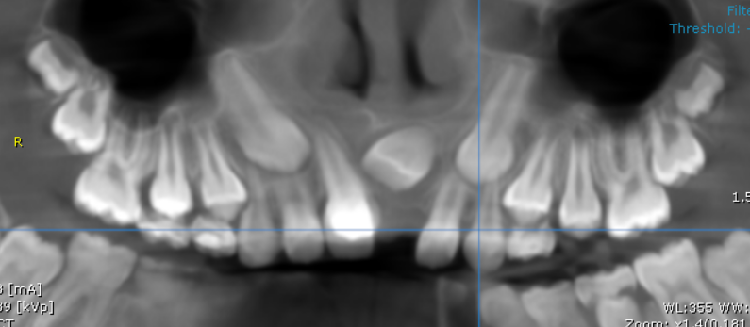
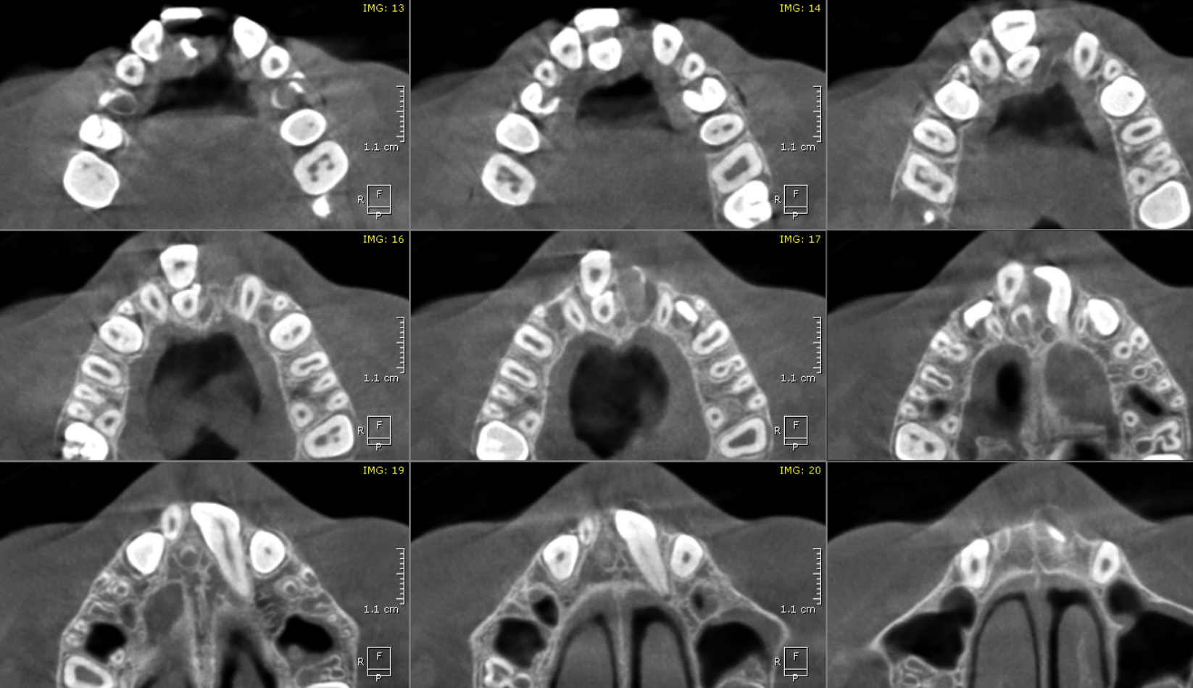
AXIAL IMAGES
CROSS- SECTIONAL IMAGES

11 REGION | 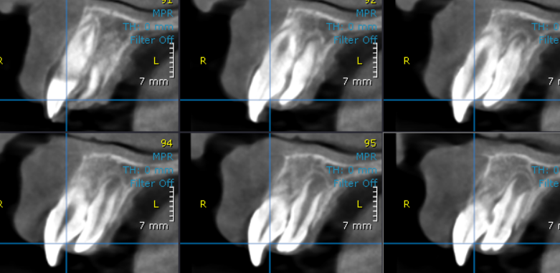
Position of 11 and the impacted supernumerary tooth | 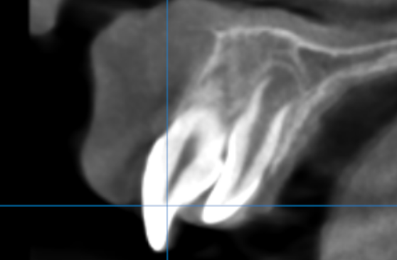

3-DIMENSIONAL VIEW

Tooth 11

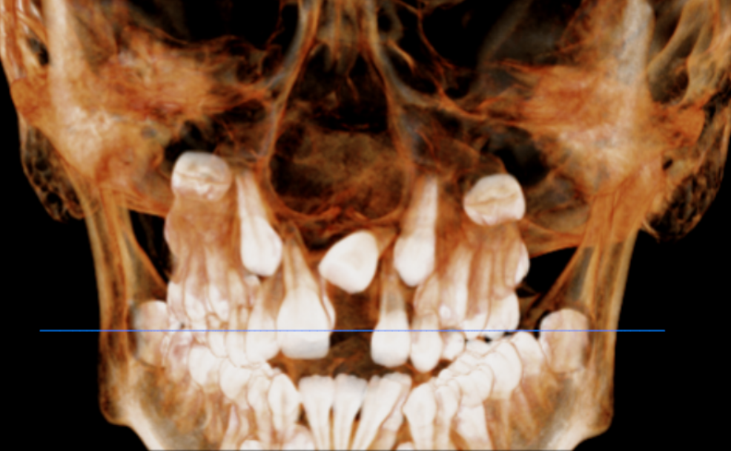

Impacted tooth 21

Impacted Supernumerary tooth located palatally

**** End of report ****

